2014-FI-01-EN Search tree
0 ---- | I: ---- | II: ---- | III: medium | IV: easy

Answer Type: Open Integer Mandatory for: none

Body

A search tree, which contains numbers, is a structure, where all numbers that are less than the number in that node, are on the left to that node. Similarly all the numbers, that are greater than or equal to the number in the node are on the right to that node.
A balanced search tree is such that there is the same number of nodes to the left and right of a certain node.
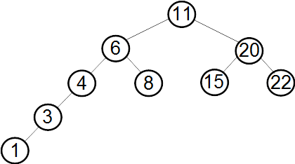

Question

What number will be in the top (root) node of the search tree, if this tree was balanced?

Answer

8

Explanation

The root node is the centermost one.

It's informatics

Binary tree is a data structure widely used in computer science. Binary search trees can be used for example to implement an efficient sorting algorithm.

Keywords

Tree, search tree, sort

Websites

http://en.wikipedia.org/wiki/Binary_tree
http://en.wikipedia.org/wiki/Binary_search_tree

Internal Use

Wording

Comments

Juha Vartiainen, 2014-06-02, svg-graphics added

Graphics

Files

2014-FI-01-EN.odt (this file)
searchtree.svg

Authorship

Juha Vartiainen, juha.vartiainen@gmail.com , Finland
Linda Mannila, linda.mannila@abo.fi, Finland

License

Copyright © 2014 Bebras – International Contest on Informatics and Computer Fluency. This work is licensed under a Creative Commons Attribution-NonCommercial-ShareAlike 3.0 Unported License (CC BY-NC-SA 3.0). Visit: http://creativecommons.org/licenses/by-sa-sa/3.0/

